Table of Contents
Activity 1: Collaborative Database Design 2
1. Database design: University Course Management System 2
Courses 2
Students 2
Enrollments 2
2. ERD Diagram 3
3. SQL CREATE TABLE statements 3
Activity 2: Shared SQL Query Challenges 4
1. Query using joins 4
2. Query using aggregate function 5
3. Query using nested subquery 5
Activity 3: Troubleshooting 6
1. Faulty schema example 6
2. Issue 6
3. Corrected schema 6
4. Faulty query example 6
5. Issue 7
6. Corrected query 7
Activity 4: SQL in Practice 7
1. Bookstore sales report query 7
2. Summary report: total spending per customer 8

Activity 1: Collaborative Database Design

1. Database design: University Course Management System
Entities and attributes

Courses
Attribute | Description
CourseID | Primary key for each course
CourseName | Name of the course
CourseCode | Unique course code
Credits | Number of credits
Lecturer | Name of lecturer

Students
Attribute | Description
StudentID | Primary key for each student
FirstName | Student first name
LastName | Student last name
Email | Student email
Phone | Student phone number

Enrollments
Attribute | Description
EnrollmentID | Primary key for each enrollment
StudentID | Foreign key linked to Students
CourseID | Foreign key linked to Courses
EnrollmentDate | Date student enrolled
Grade | Student grade

2. ERD Diagram
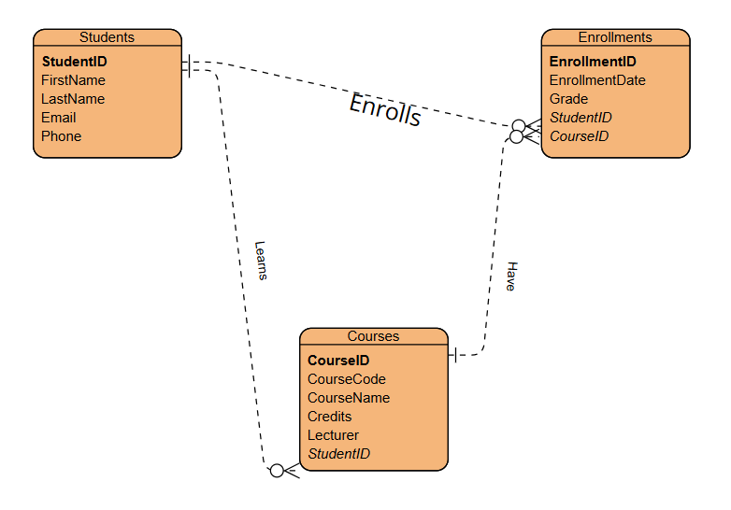

3. SQL CREATE TABLE statements
CREATE TABLE Students (
StudentID INT PRIMARY KEY,
FirstName VARCHAR(50),
LastName VARCHAR(50),
Email VARCHAR(100),
Phone VARCHAR(20)
);

CREATE TABLE Courses (
CourseID INT PRIMARY KEY,
CourseName VARCHAR(100),
CourseCode VARCHAR(20),
Credits INT,
Lecturer VARCHAR(100)
);

CREATE TABLE Enrollments (
EnrollmentID INT PRIMARY KEY,
StudentID INT,
CourseID INT,
EnrollmentDate DATE,
Grade VARCHAR(5),
FOREIGN KEY (StudentID) REFERENCES Students(StudentID),
FOREIGN KEY (CourseID) REFERENCES Courses(CourseID)
);

Activity 2: Shared SQL Query Challenges

1. Query using joins
SELECT
Students.FirstName,
Students.LastName,
Courses.CourseName,
Enrollments.EnrollmentDate,
Enrollments.Grade
FROM Enrollments
INNER JOIN Students
ON Enrollments.StudentID = Students.StudentID
INNER JOIN Courses
ON Enrollments.CourseID = Courses.CourseID;

2. Query using aggregate function
SELECT
Courses.CourseName,
COUNT(Enrollments.StudentID) AS TotalStudents
FROM Courses
LEFT JOIN Enrollments
ON Courses.CourseID = Enrollments.CourseID
GROUP BY Courses.CourseName;

3. Query using nested subquery
SELECT
FirstName,
LastName,
Email
FROM Students
WHERE StudentID IN (
SELECT StudentID
FROM Enrollments
WHERE CourseID = (
SELECT CourseID
FROM Courses
WHERE CourseName = 'Database Systems'
)
);

Activity 3: Troubleshooting

1. Faulty schema example
CREATE TABLE Enrollments (
EnrollmentID INT PRIMARY KEY,
StudentID INT,
CourseID INT,
EnrollmentDate DATE,
Grade VARCHAR(5)
);

2. Issue
One difficulty with this schema is that it lacks foreign key constraints. This shows that inaccurate StudentID or CourseID entries may be written to the Enrollments table even if a student or course does not exist.

3. Corrected schema
CREATE TABLE Enrollments (
EnrollmentID INT PRIMARY KEY,
StudentID INT,
CourseID INT,
EnrollmentDate DATE,
Grade VARCHAR(5),
FOREIGN KEY (StudentID) REFERENCES Students(StudentID),
FOREIGN KEY (CourseID) REFERENCES Courses(CourseID)
);

4. Faulty query example
SELECT StudentID, CourseID
FROM Students
INNER JOIN Enrollments
ON StudentID = StudentID;

5. Issue
This query is ambiguous since a StudentID column can be present in both tables. The join condition is also flawed since StudentID = StudentID does not indicate which table each column comes from.

6. Corrected query
SELECT
Students.StudentID,
Students.FirstName,
Students.LastName,
Enrollments.CourseID
FROM Students
INNER JOIN Enrollments
ON Students.StudentID = Enrollments.StudentID;

Activity 4: SQL in Practice

1. Bookstore sales report query
SELECT
Customers.Name AS CustomerName,
Books.Title AS BookPurchased,
Sales.Quantity,
Books.Price,
Sales.Quantity * Books.Price AS TotalSpent
FROM Sales
INNER JOIN Customers
ON Sales.CustomerID = Customers.CustomerID
INNER JOIN Books
ON Sales.BookID = Books.BookID;

2. Summary report: total spending per customer
SELECT
Customers.Name AS CustomerName,
SUM(Sales.Quantity * Books.Price) AS TotalSpending
FROM Sales
INNER JOIN Customers
ON Sales.CustomerID = Customers.CustomerID
INNER JOIN Books
ON Sales.BookID = Books.BookID
GROUP BY Customers.Name
ORDER BY TotalSpending DESC;

